**Case**

SUNIB restaurant wants to create a program to manage the queue reservation. You are asked to create the program with the following additional information:

1. SUNIB restaurant manages the queue based on the membership system they have. The membership status is in the following order: VVIP, VIP, Member, and Guest.
2. If the customer has the same membership status, then it is First In First Serve.
3. There are five menus that have to be available in the program: Add Customer to Queue, Serve One, Serve All, Dismiss Queue, and Exit.
4. Add Customer to Queue à to add the customer along with the information to the queue. The customer information should be inputted in the following format:

“[Membership Status] [Customer Name]”

1. Serve One à to call the first customer in line with the following statements:
   1. If membership is VVIP, “Attention! [customer-name] is being served at VVIP table.”
   2. If membership is VIP, “Attention! [customer-name] is being served at the VIP table.”
   3. If membership is Member, “Attention! Member [customer-name] is being served at regular table.”
   4. If membership is Guest, “Attention! Guest [customer-name] is being served at a regular table.”

After serving a customer, pop or remove the customer from the queue line.

1. Serve All à to call all the remaining customers in line using the same statements at point 5 for each customer. Pop or remove all customers from the queue line.
2. Dismiss Queue à display “End of the day.” and pop or remove all customers from queue line.
3. Exit à to exit the program.
4. When the main program is executed, the program will always display the waiting line conditions.
5. Run the menu by simply inputting the menu number.

**Main Program Sample:**

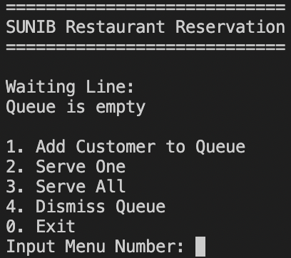

**Sample Menu 1:**

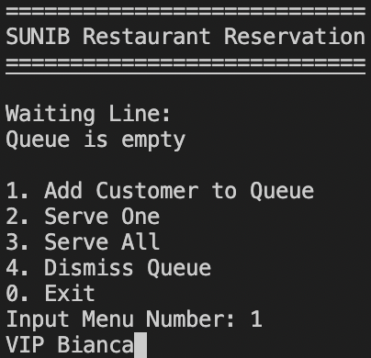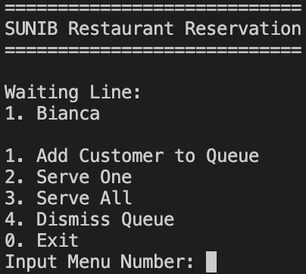

**Sample Menu 2:**

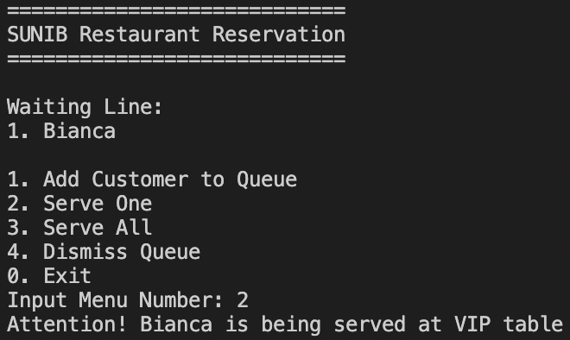

**Sample Menu 3:**

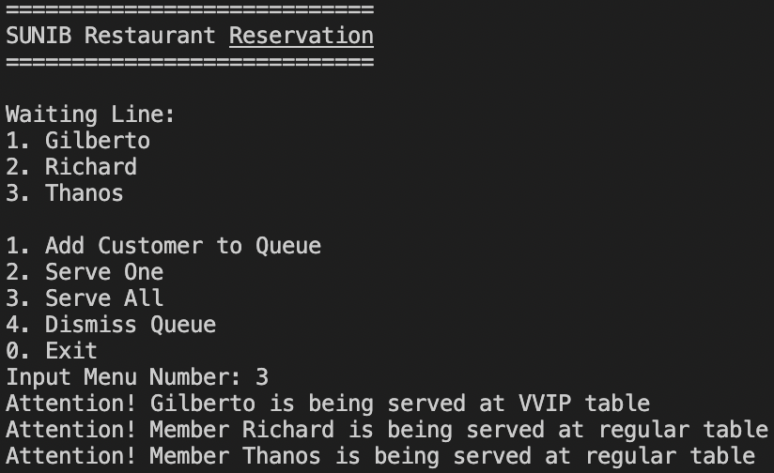

**Sample Menu 4:**

